Given the head of a sorted linked list, *delete all duplicates such that each element appears only once*. Return *the linked list****sorted****as well*.

**Example 1:**

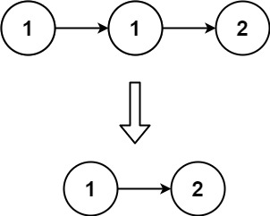

**Input:** head = [1,1,2]

**Output:** [1,2]

**Example 2:**

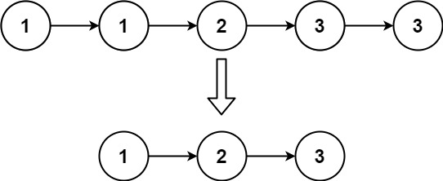

**Input:** head = [1,1,2,3,3]

**Output:** [1,2,3]

**Constraints:**

* The number of nodes in the list is in the range [0, 300].
* -100 <= Node.val <= 100
* The list is guaranteed to be **sorted** in ascending order.